**Tables in HTML**

- Tables are used to organize our content into rows and cols.

- Presenting data in Grid Form

- The tags used for tables

|  |  |
| --- | --- |
| **Tag** | **Description** |
| *<table>* | To encapsulate all rows and columns.  It is a container with caption, header, body and footer. |
| *<caption>* | It is used to define a caption for table. |
| *<thead>* | It defines the table header section. |
| *<tbody>* | It defines the table body section. |
| *<tfoot>* | It defines the table footer section. |
| *<colgroup>* | It groups a set of columns to define styles. |
| *<tr>* | It defines a table row. |
| *<th>* | It defines header text. |
| *<td>* | It defines cell content. |

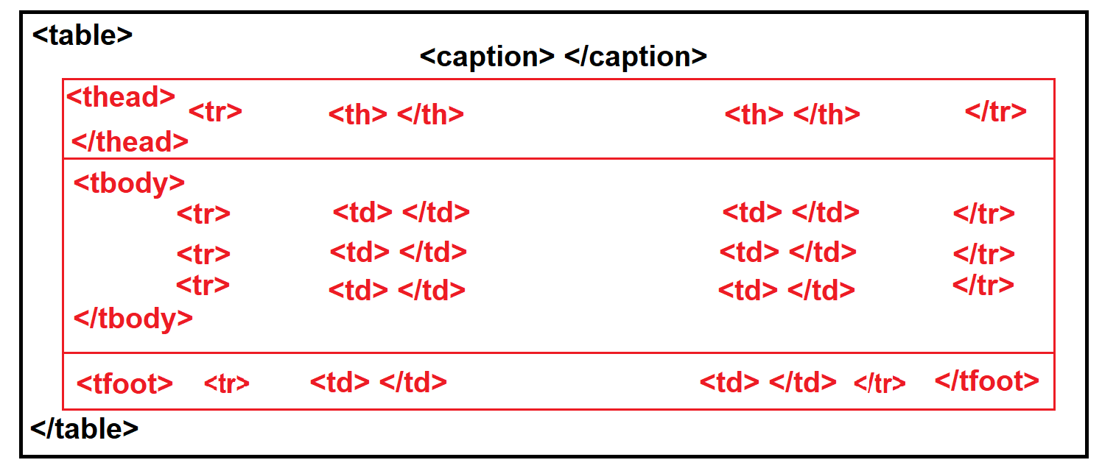

<!DOCTYPE html>

<html>

    <head>

        <title>Tables in HTML</title>

        <link rel="stylesheet" href="Fonts/css/all.css">

    </head>

    <body>

        <table>

            <caption>Shopping Cart</caption>

            <colgroup span="1"></colgroup>

            <thead>

                <tr>

                    <th>Name</th>

                    <th>Price</th>

                    <th>Preview</th>

                    <th>Actions</th>

                </tr>

            </thead>

            <tbody>

                <tr>

                    <td>JBL Speaker</td>

                    <td>&#8377; 4500/-</td>

                    <td><img src="Images/jblspeaker.jpg" width="50" height="50"></td>

                    <td><span class="fa fa-trash"></span></td>

                </tr>

                <tr>

                    <td>Shirt</td>

                    <td>&#8377; 2500/-</td>

                    <td><img src="Images/shirt.jpg" width="50" height="50"></td>

                    <td><span class="fa fa-trash"></span></td>

                </tr>

                <tr>

                    <td>Nike Casuals</td>

                    <td>&#8377; 6500/-</td>

                    <td><img src="Images/shoe.jpg" width="50" height="50"></td>

                    <td><span class="fa fa-trash"></span></td>

                </tr>

            </tbody>

            <tfoot>

                <tr>

                 <td>Bill Summary</td>

                 <td>&#8377; 23000/-</td>

                </tr>

            </tfoot>

        </table>

    </body>

</html>

**Table Attributes**

1. **Border, Frame and Rules**
   1. Border : It defines border for cells.

You can define border value 1=ON Border, 0=OFF Border.

* 1. Frame : It defines a frame for table.   
      You can define frame with the values “**box, rhs, lhs, above, below, void”.**
  2. Rules : It defines rules for rows and columns.  
      You can define rules with values “**all, rows, cols, groups, none”.** Rules can’t be defined for table when it is specified with **border**. If border

and rules both are specified then only rules will display.

**Ex:**

**<table border=”1” frame=”void”>** Border for cells only.

**<table border=”1” frame=”box”>** Border with Frame.

**<table border=”0” frame=”box”>** Only Frame without border.

**<table rules=”groups” frame=”box”>** Rules with frame.